**CMPS 312– Fall 2024**

**Lab** **Midterm Exam**

|  |  |  |  |
| --- | --- | --- | --- |
| Name |  | Grade |  |
| **100** |
| QUID |  | Section |  |

PLEASE READ THE FOLLOWING INSTRUCTIONS CAREFULLY

1. The exam duration is **120** minutes. So, read the exam questions carefully and plan your time accordingly.
2. Once you complete the exam, push to your GitHub repository the following,
   1. The flutter project code
   2. Submit screenshots of your app’s functionality in the provided Midterm Testing-GradingSheet.docx. Failure to submit screenshots will result in a 10-point deduction.
3. Push to your repo regularly to avoid unpleasant surprises; as a computer hang or program shutdown ☹.
4. The Exam is **Open Book** , but you are not allowed to use any AI tools. Incase of plagiarism you will receive **- 0 points** . Hence do not share or receive any code from anyone.

**GOOD LUCK ON YOUR EXAMINATION!**

**Flash News App**

**Objective**: Build a News App using Flutter to demonstrate your mobile development skills.

**Instructions:**

You are required to implement the app using the following key Flutter concepts: **State Management with Riverpod**, **Navigation with GoRouter**, **UI Components** (e.g., ListView, Dropdown, TextFields), and **JSON Data Handling**. Ensure your app adheres to these concepts, as they are essential for full credit.

* **Sync your Lab repository** and then copy the provided midterm folder to your GitHub repository. This folder contains an empty solution pre-configured with all necessary dependencies and assets required for the exam.
* **Follow the tasks below carefully** to ensure all requirements are met.

**Implementation Tasks:**

**1) News List Screen**

* Create a News List screen that displays a list of news articles. The list should be populated from the articles.json under the assets folder.
* Each news article entry should include the title, a brief summary, a category tag, author name, publication date, and an image.
* Implement filter news articles by category: All, Politics, Technology, or Business. Then dynamically update the list to display news articles in the selected category.

**2) Add News Screen**

Figure News List Screen

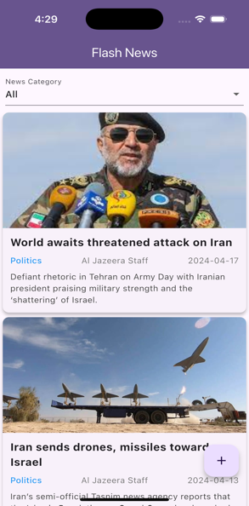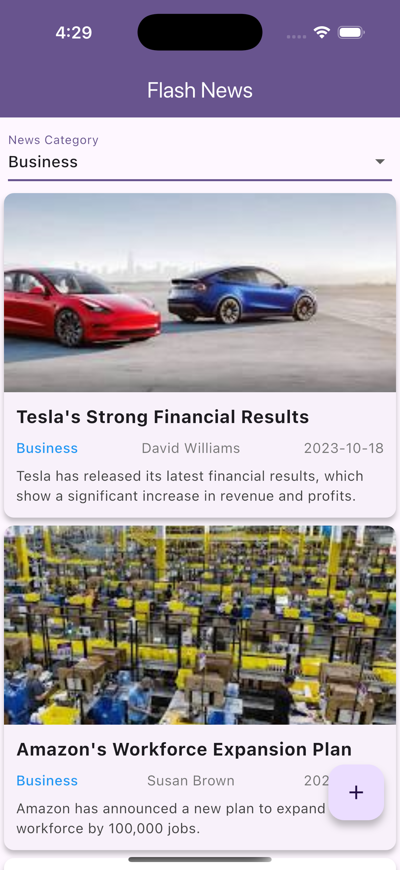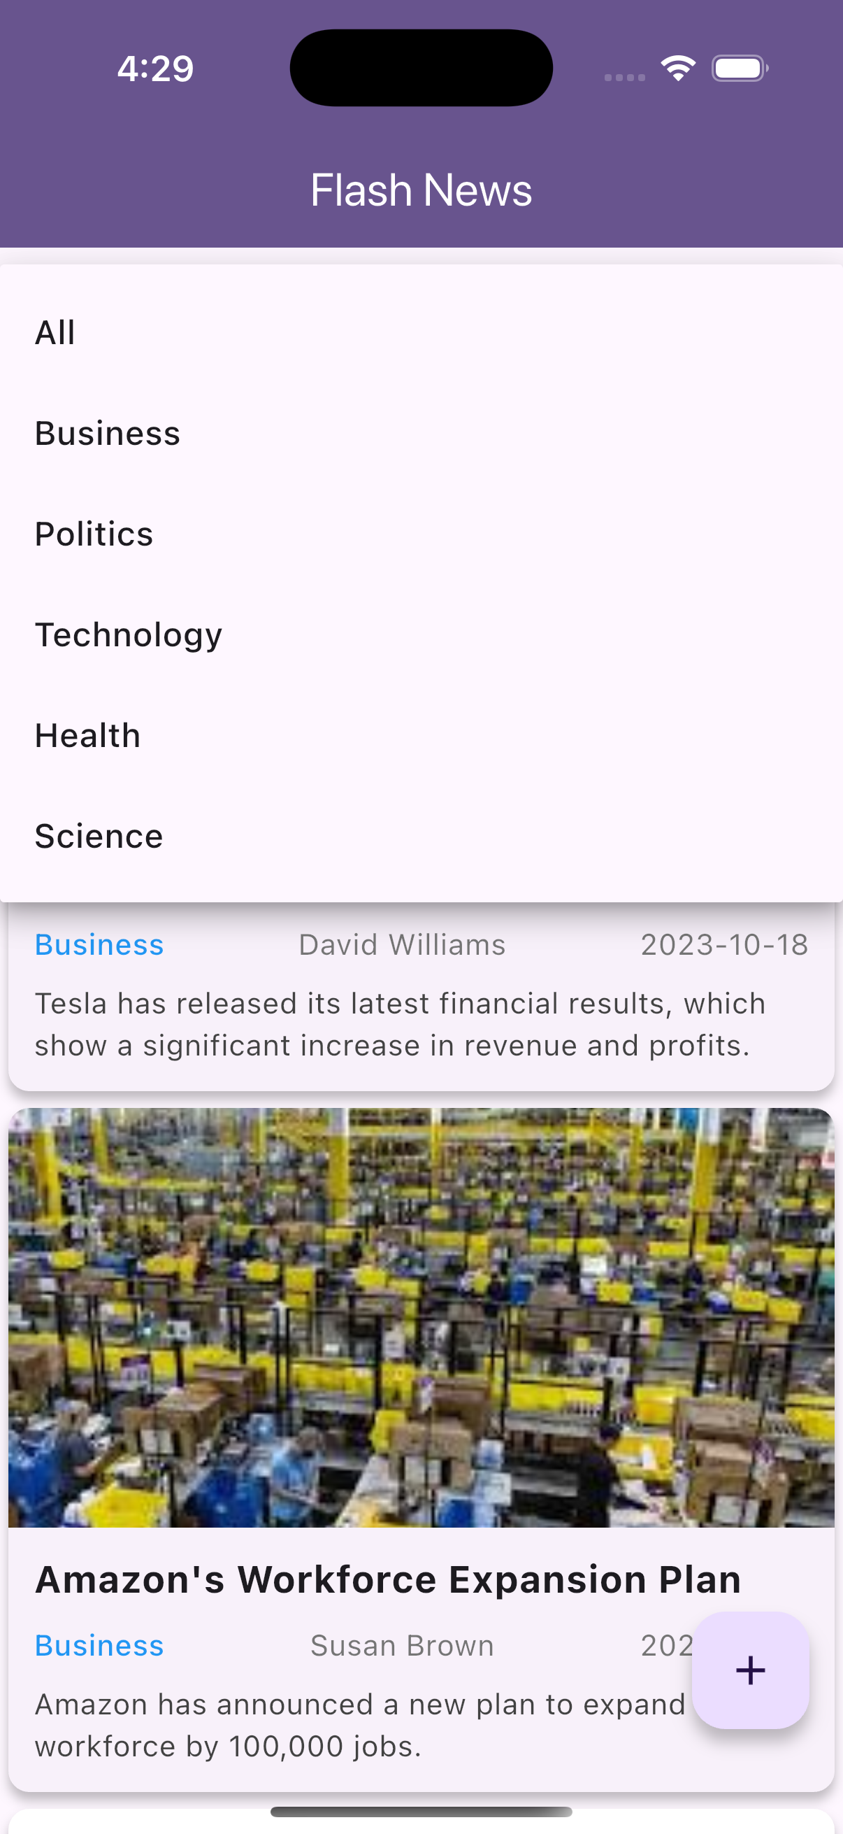

* Create an Add News screen that allows users to add new news article.
* Users should be able to enter the title, the article's content, choose a category from a dropdown, provide the author's name, and set the publication date.
* Also, implement an option for users to enter image name an image in the assets to associate with the news article. For testing, use any of the available images in the assets folder.
* Include "**Add Article**" button that stores the user-added news article in the list of articles.
* When the news article is added, it should be immediately visible in the News List.

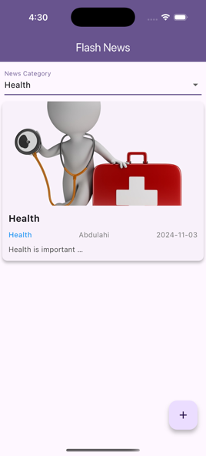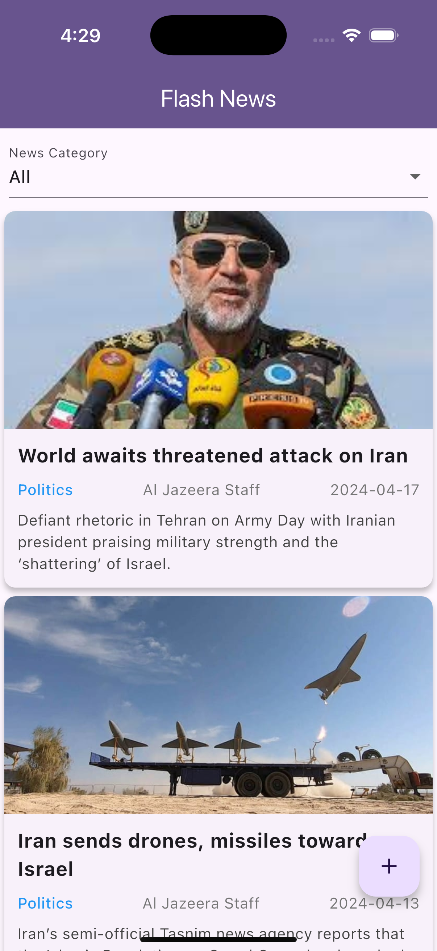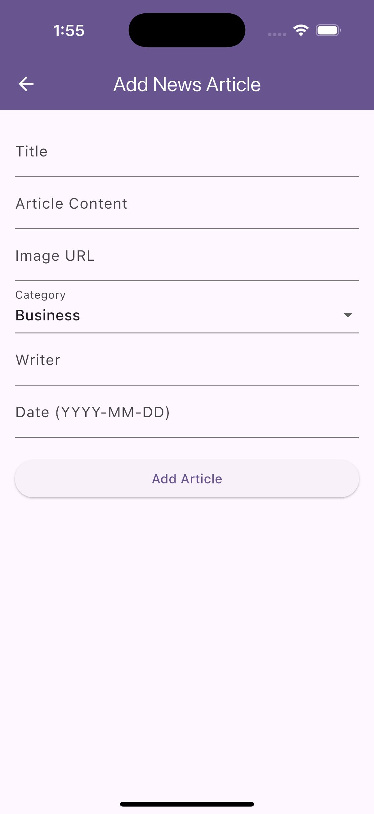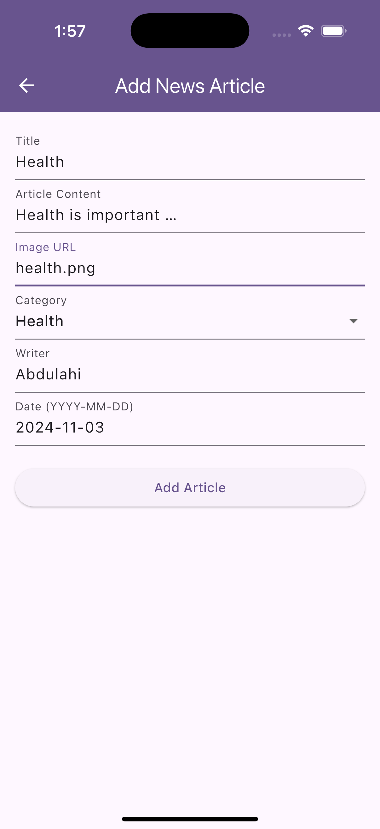

Figure : Add New Article

**Grading Rubrics**

|  |  |  |  |  |
| --- | --- | --- | --- | --- |
| Criteria | % | Functionality* | Quality of the implementation | Score |
| **News List Screen (70%)**   * Successfully displayed the list of news articles from the JSON file as per the design shown in Figure 1. * Properly implemented filter news articles by category. | 70 |  |  |  |
| **Add News Screen (30%)**   * Correctly designed and implemented the Add News form. * Successfully add the news article to the list of articles. Plus demonstrate the ability to display the newly added news article in the list. | 30 |  |  |  |
| Provide screenshots in *testing.docx* | - |  | *[-10pts if missing]* |  |

**Possible grading for functionality**:

* ***Complete and Working*** (get 70% of the assigned grade),
* ***Complete and Not working*** (lose 40% of assigned grade)
* ***Not done*** get 0.
* The remaining grade is assigned to the quality of the implementation.
* Must submit screenshots in this **Midterm Testing-GradingSheet.docx** (otherwise - 10pts).